Digital Content Feed

Phase 1 Report

Submitted By: - Sammy student

Axxxxxxxx sstudent01@hawk.iit.edu

# ITMD xxx

03/24/2024

Project Description

This project is to create an android application that will generate digital content like news, articles and stories for a user based upon their interests. A user can select any topics of interest from various available choices like business, entertainment, general, health, science, sports and technology. Once the topics are selected the application will then present the user with various articles based on their interests.

The application will also have the functionality to bookmark an article, like an article and share the article.

This application also needs users to be registered before they can view their personalized feed.

The application will also make use of firebase database to implement the article bookmark and like functionality.

Firebase functions will be used to fetch the articles for the topics selected by the user. These functions can make use of NEWS API to select the data.

Once the data is fetched by firebase functions, our application can then call these function endpoints to present the user with the data.

Sketches of Various Activit y Screens

1. Splash Screen

When the users start the application, they will be shown this screen for a small interval of time, it will then change automatically.



1. Sign up Activity

This activity will be shown after the splash screen if the user is not signed in. This will allow the user to sign in using Facebook, Gmail or an email. Firebase authentication will be used.

If Sign up with

email is selected

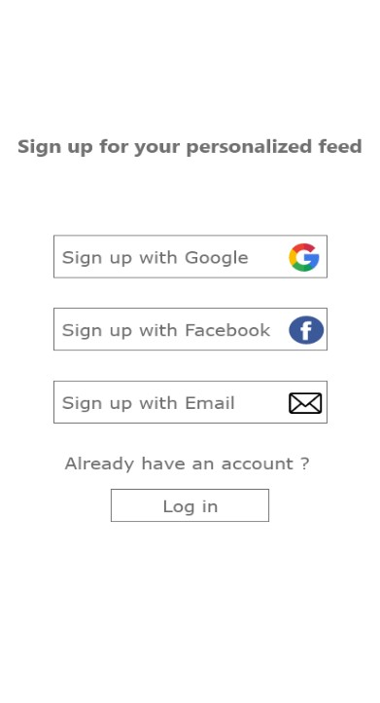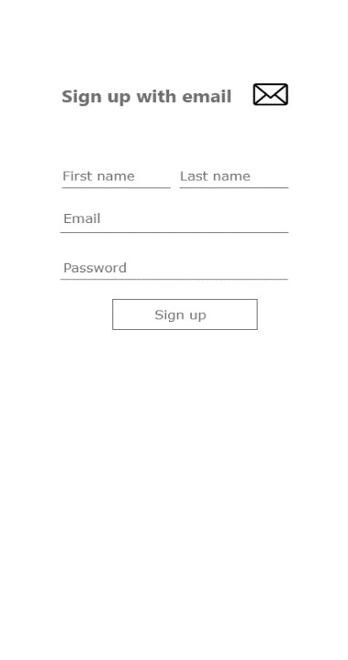

1. Sign in/ Login Activity

This activity will allow user to sign in. A user needs to be signed in before using this application. Here the user enters the login information

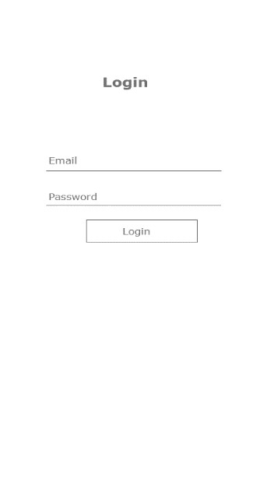

1. Topic Selectivity Activity

This screen will allow user to select the topics of their interests before they can be presented with the personalized feed. The topics selected here will help generate the feed.

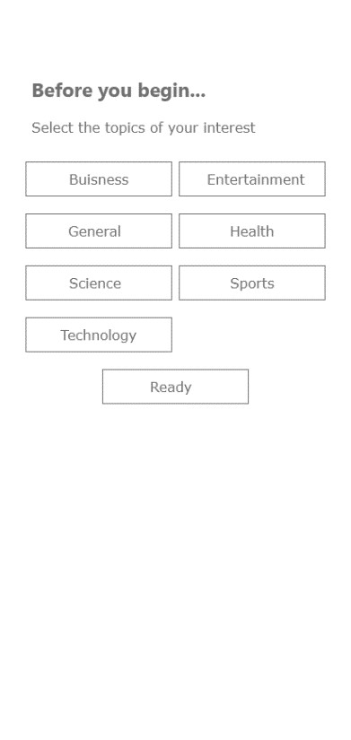

1. Home Activity

On this screen the user will be presented with the list of articles based on the topics selected on the previous screen. If the user is already logged in this screen will be presented right after the splash screen

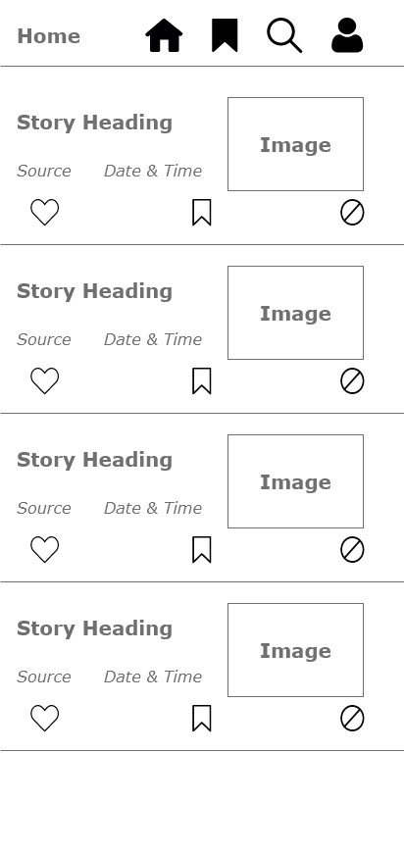

L

ike

Bookmark

Remove

Source

1. Detail Activity

If the user selects an article to read, it will open the url for that article with the detail view.

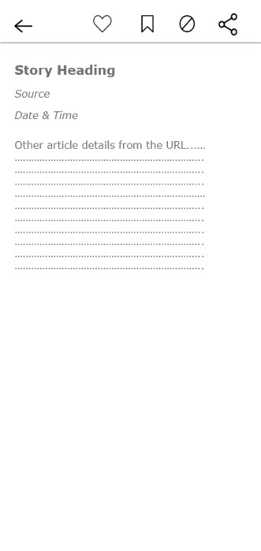

Share

1. Bookmark Activity

This activity will contain all the bookmarked articles

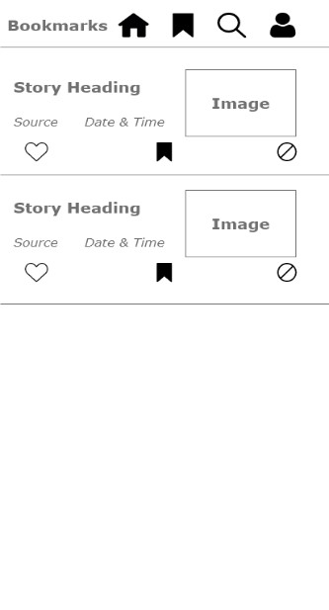

1. Search Activity

This screen will allow the user to input query string to search articles based on it.

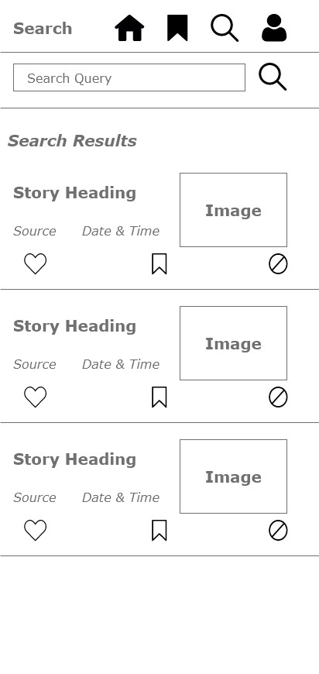

High Level Flow Diagram for all these activities

Is

Logged dgahda

i

n

?

Splash Screen

No

Yes

Sign up Activity

Already

h

a

ve

an

Account

?

No

Yes

Sign up

Login

Activity

Home

Activity

Bookmark

Activity

Detail

Activity

Sea

rch

Activity

S

uccess

Yes

No